The provided code is a React functional component named Footer, representing the footer section of a web page. This component uses Tailwind CSS for styling and includes various sections with links and information.

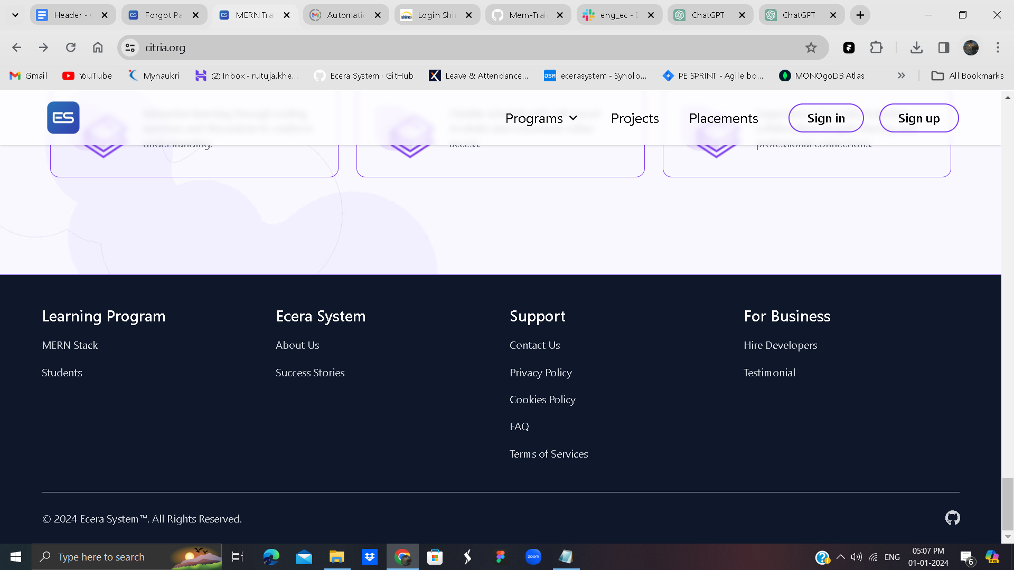

Component Structure:

Import Statement:

The component starts with an import statement to include a CSS file named 'Footer.css', suggesting additional styling for the footer.

Footer Component:

The Footer component is a functional component that returns JSX code for the footer section of a webpage.

Structure and Styling:

The footer has a full-width (w-full) background with the color 'bg-slate-900'.

The content is contained within a responsive grid (grid) with different column layouts based on the screen size (lg:grid-cols-4, sm:grid-cols-2, grid-cols-2).

Sectional Links:

The footer is divided into four sections, each represented by an unordered list (<ul>) containing list items (<li>) with links.

Each section has a heading (<h2>) with a white color and larger font size.

Links within each section are styled with hover effects, including underlining and color changes.

Horizontal Line:

A horizontal line (<hr />) is added after the sections for visual separation.

Copyright and Social Links:

The copyright information (&copy; {new Date().getFullYear()} Ecera System™. All Rights Reserved.) is displayed at the bottom.

Social media links (e.g., GitHub) are present with corresponding icons and hover effects.

Responsive Layout:

The layout is responsive, adapting the number of columns based on the screen size (using Tailwind CSS responsive classes).

External Links:

Some links are external, leading to the Ecera System website and GitHub.